General Steps

Obtain Virtual tour framework 1

Create virtual tour with Marzipano Tool and 360 images 1

Create Mozilla Hub and link 4

Open Mozilla Hub and Share 6

Link 360 VT and Mozilla Hub 7

## Download Virtual Tour Framework

1. Download Github repository <https://github.com/Insa-Maria/Virtual_Tour> by clicking on the green button “Code” and then “Download ZIP”
2. Save “Virtual_Tour-master.zip” and “Extract all”

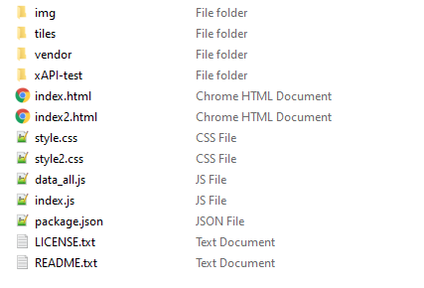

1. For future reference, this folder will be called “Virtual_Tour_Framework” in this tutorial.

## Create Virtual Tour with Marzipano Tool and 360 images

1. Navigate to <https://www.marzipano.net/> (you can explore some Demo and Documentation
2. Click on “Marzipano Tool”, top left button
3. Click on “Start” and “Select files” to add the 360 images

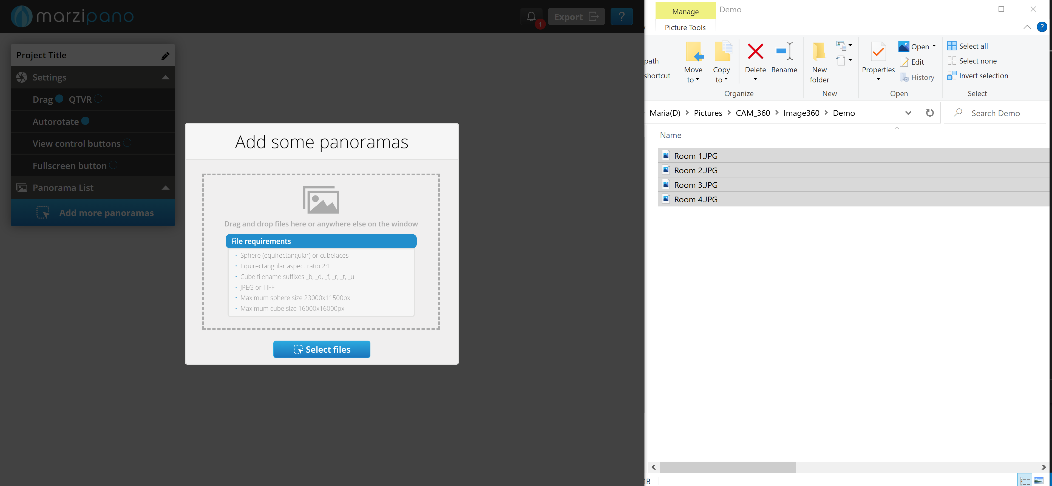  
Note: By default, the file name is set as the 360image title in the web-based Virtual tour.

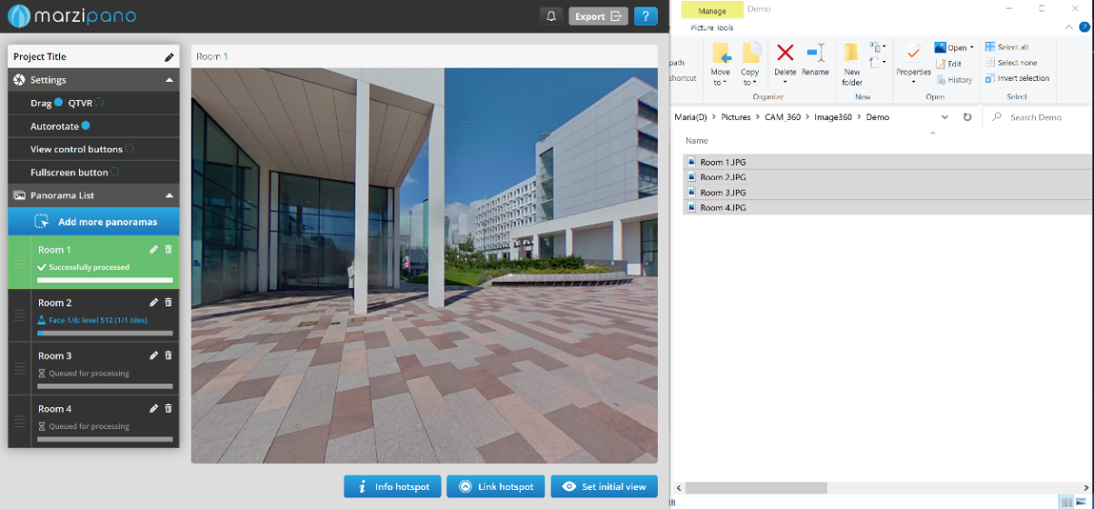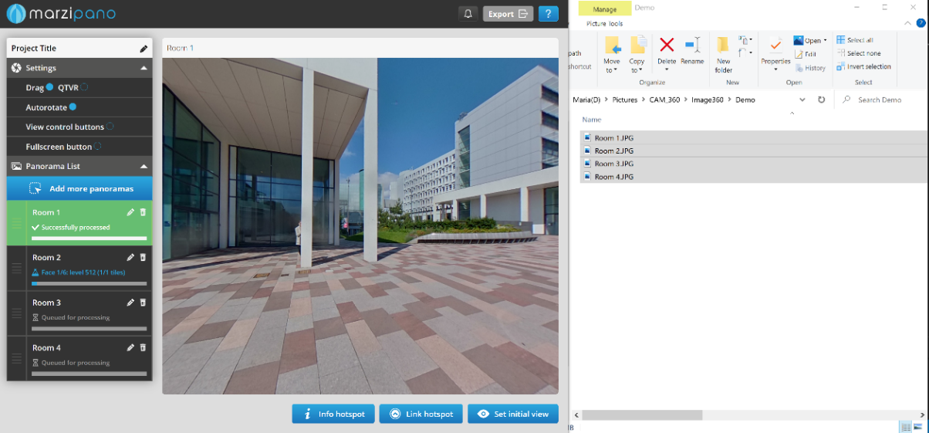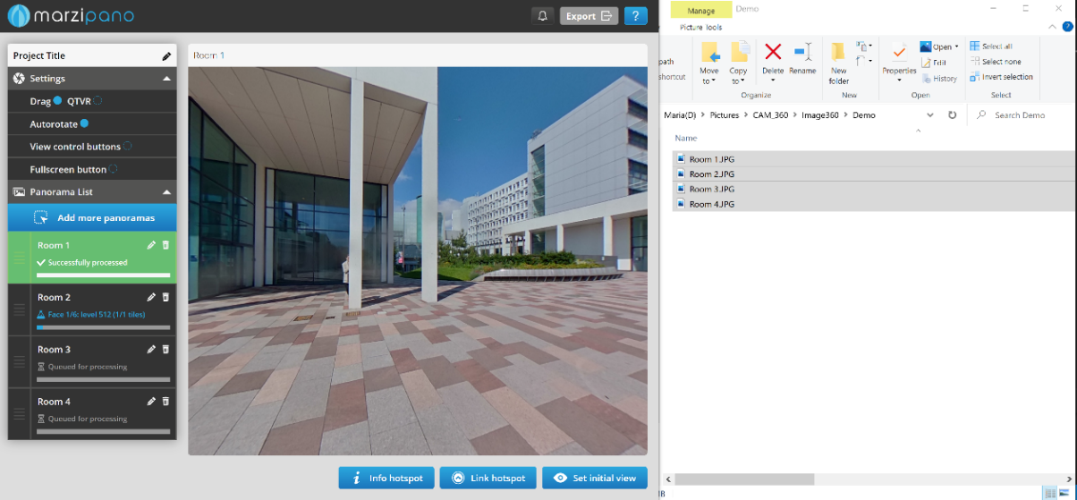

1. Set the “Project Title” and “Settings”
2. Export the project by clicking on the top left button. Save the .zip file (i.e. project-title.zip) and "Extract all”
3. Open the “project-title” folder and open the folder called “app-files”
4. To run the Marzipano Virtual Tour, right click on the “index.html” file and open with a browser (i.e. Google Chrome).  
   Note: A black screen with the “info” button may appear and the menu bar may appear. To fix this error:

(1) close ALL Google Chrome,

(2) on your windows bar, search for “Run” app,

(3) type “Chrome with --allow-file-access-from-files %1”

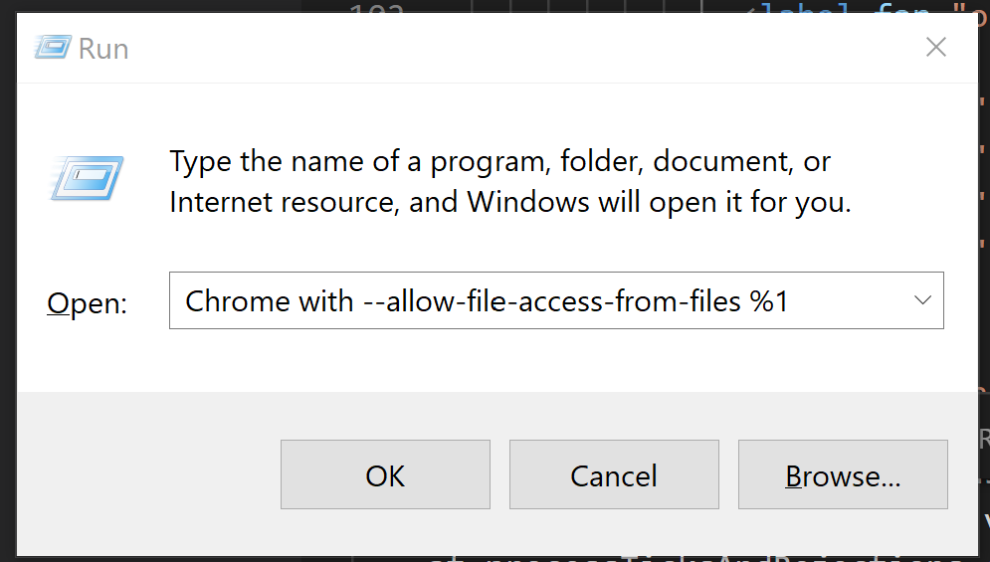

1. For future reference, this folder will be called “Marzipano_Virtual_Tour” in this tutorial.

## Customise Virtual Tour to your Organisation

In this step, “Marzipano_Virtual_Tour” files are edited and copied to “Virtual_Tour_Framework” folder.   
*Note: I highly recommend after each step, run the “Organisation_Virtual_Tour/index.html” file, (right click on the “index.html” > open with a browser (i.e. Google Chrome)) to ensure the changes are performed correctly.*

1. Open on two different windows:
   1. “Organisation_Virtual_Tour” folder (downloaded from GitHub)
   2. “Marzipano_Virtual_Tool” folder (exported from Marzipano Tool)

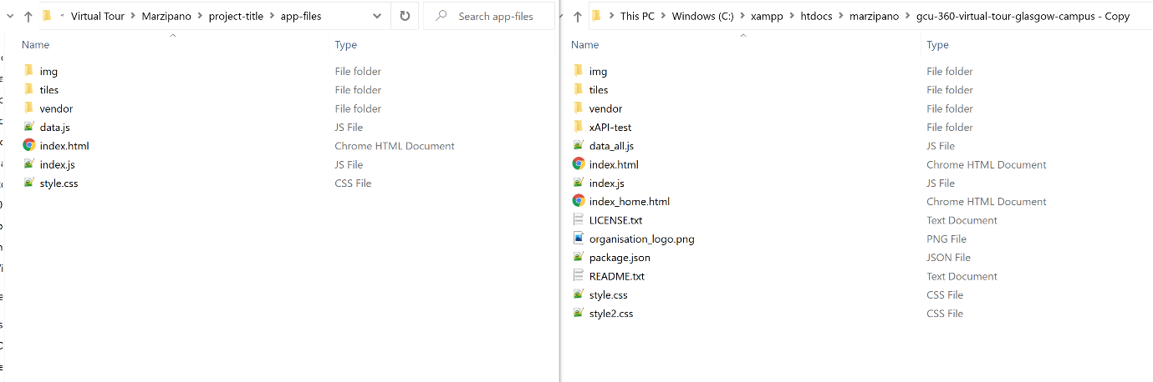

1. Copy and Replace the “Marzipano_Virtual_Tool/style.css” file to “Organisation_Virtual_Tour” folder.
2. 

Organisation_Virtual_Tour

Marzipano_Virtual_Tour > img

1. Delete all folder in tiles from “Organisation_Virtual_Tour” folder
2. Open “Organisation_Virtual_Tourttiles” and delete all folders. Open “Marzipano_Virtual_Tool/tiles” , copy-paste the folder to Open “Organisation_Virtual_Tour/tiles”

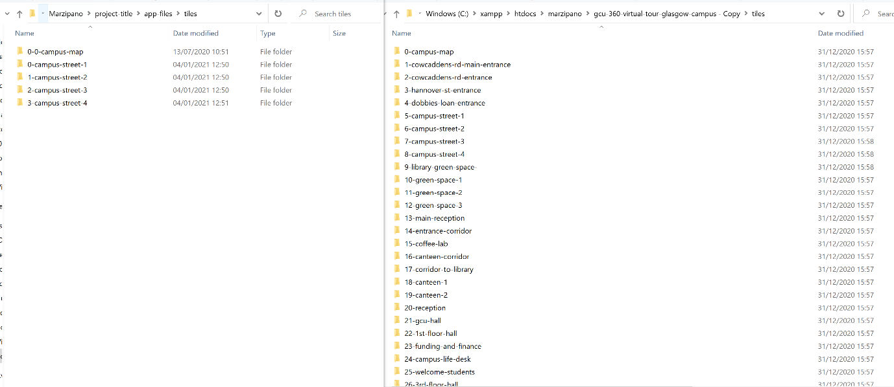

Organisation_Virtual_Tour > img

Marzipano_Virtual_Tour > img

1. (read bellow Note first) Copy and Replace the “Marzipano_Virtual_Tool/data.js” file to “Organisation_Virtual_Tour” folder.  
   *Note: I recommend saving somewhere the “Organisation_Virtual_Tour/data.js” file in on your desktop for future reference.*
2. 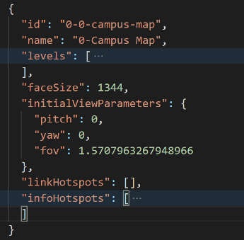Open “Marzipano_Virtual_Tour/data.js” file using an editor note (i.e. Visual Code).   
     
   The data.js collect all data relevant to 360 images (called scene, according to marzipano terminology) added to the Virtual Tour with the “info” and “link” hotspots. It is coded the following way:

* id
* name
* levels
* faceSize
* initialViewParameters
* linkHotspots
* infoHotspots

The proposed system introduces two more elements: “maplinkHotspots” and “videoHotspots”.

1. Add the bellow code to ALL scenes after the “infoHotspot”: [ … ] :

,

      "maplikHotspots": [],

      "videoHotspots": []

See an example on the bellow image:

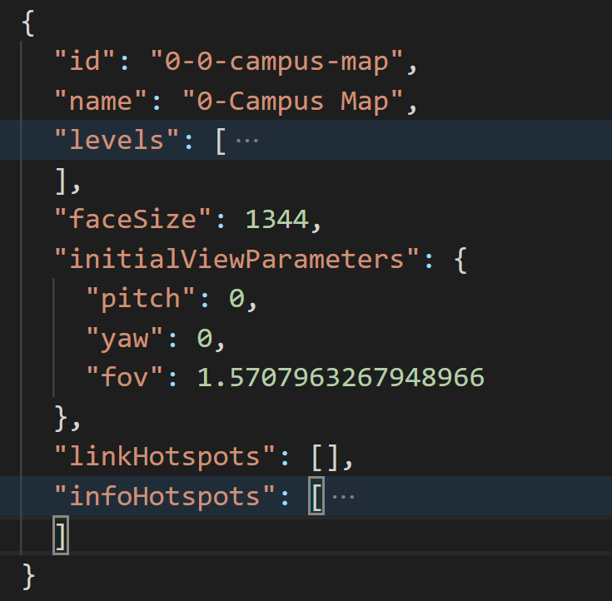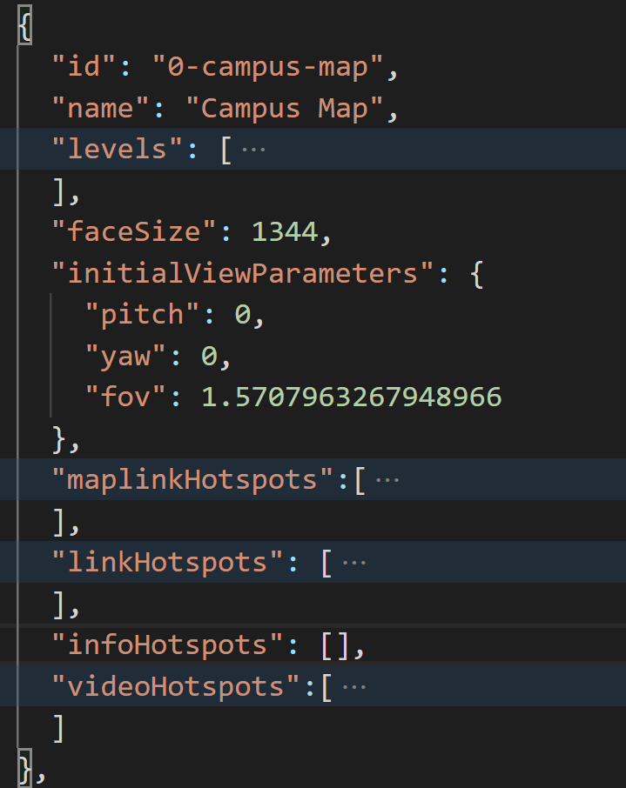

Organisation_Virtual_Tour/data.js

Marzipano_Virtual_Tour/data.js

Note: Make sure you do not mis any “,” or “() [] {}”, otherwise it will result on an error. For example, the last element “videoHotspots” do not require a “,” at the end.



Organisation_Virtual_Tour/data.js

*Note: Make sure you added the code to ALL scenes, otherwise it will result on an error.*

ACCESSIBLE MENU

The vertical menu is created with the combination of the three files: index.html (provides content), index.js (provides the functionality) and style.css (provide the style (design)). The resulting vertical menu follows the bellow structure:

, where each 360 image is coded with the following elements:

<a href="javascript:void(0)" class="scene" data-id=" 1-cowcaddens-rd-main-entrance">

<li class="text">Main Entrance</li>

</a>

Yellow- each image id on the dataset file created (data.js)

Green – title set on Marzipano tool to each 360image

Each scene needs to be re-code

<li>

<a href="javascript:void(0)" class="scene" data-id="1-cowcaddens-rd-main-entrance">Main Entrance</a>

</li>

## Create Mozilla Hub and link

1. Navigate to <https://hubs.mozilla.com/spoke>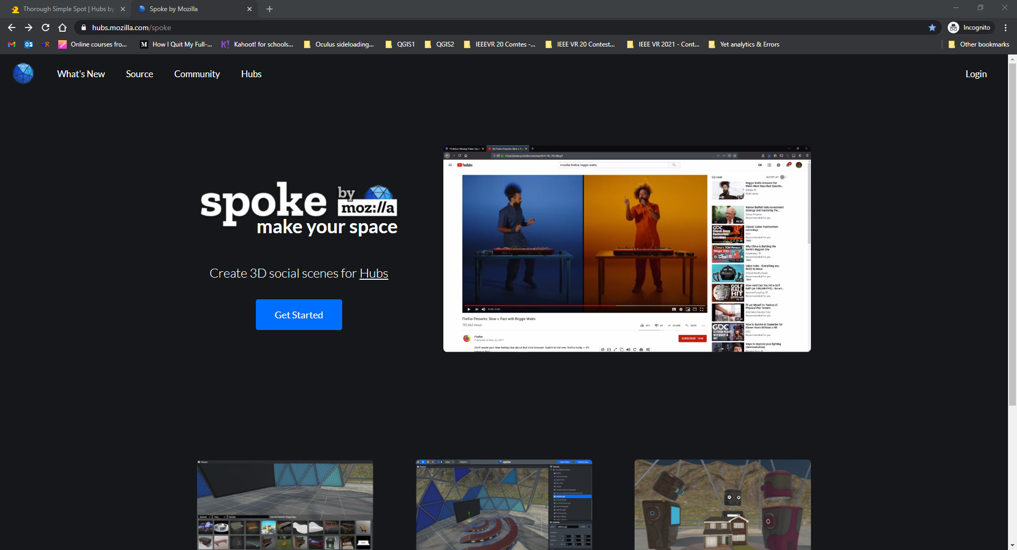
2. Click on “Get Started” and “New Project”
3. Select an environment or select the option “New Empty Project” to create a 3D environment from scratch.
4. To add (embed) the web-based Virtual Tour, activate the “Experimental Features” clicking on the menu button (displayed as ≡) > “Developer” > ”Enable Experimental Features”

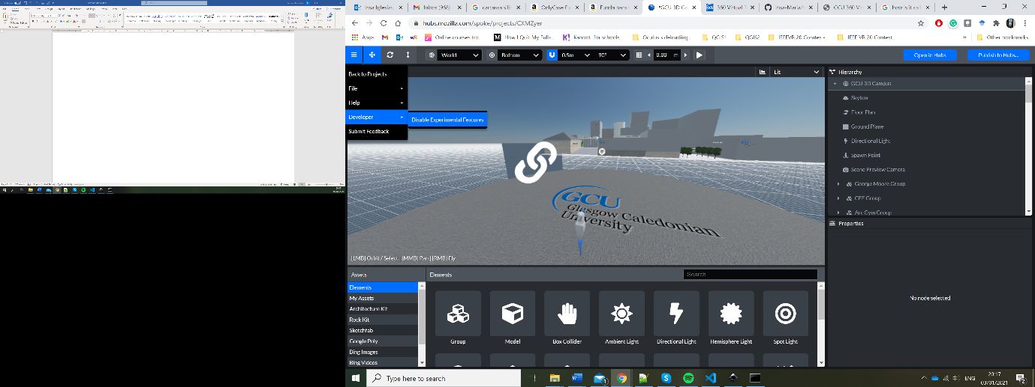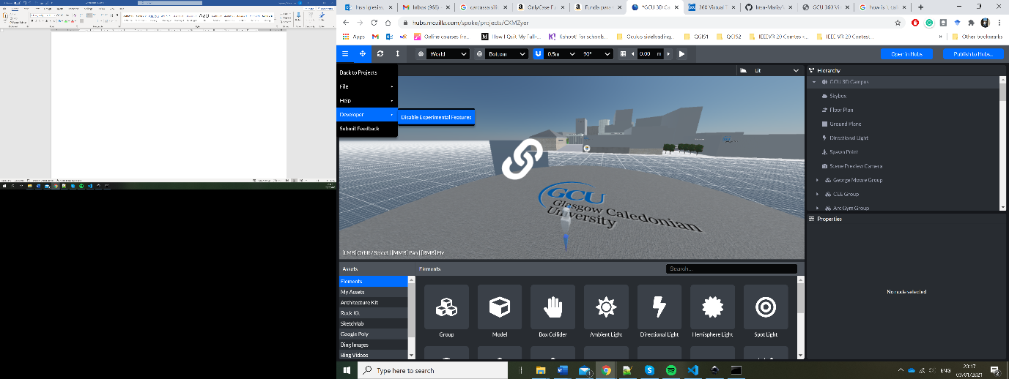

1. On the bottom navigation menu tagged “Assets”, click on “Elements” and click on “Link” to add it to the environment.

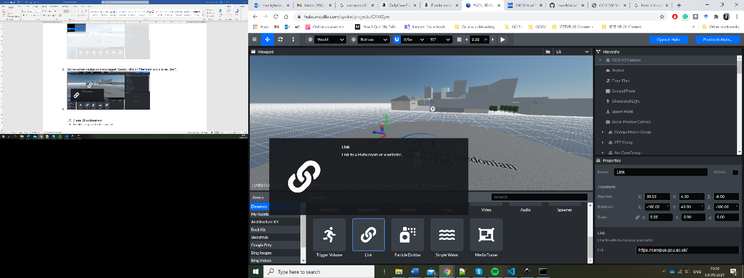

1. Set the position of the “Link” element and add the “Url” direction to any website (i.e. <https://campus.gcu.ac.uk/>). Later we will amend this url direction with the Virtual Tour, once this one is published.

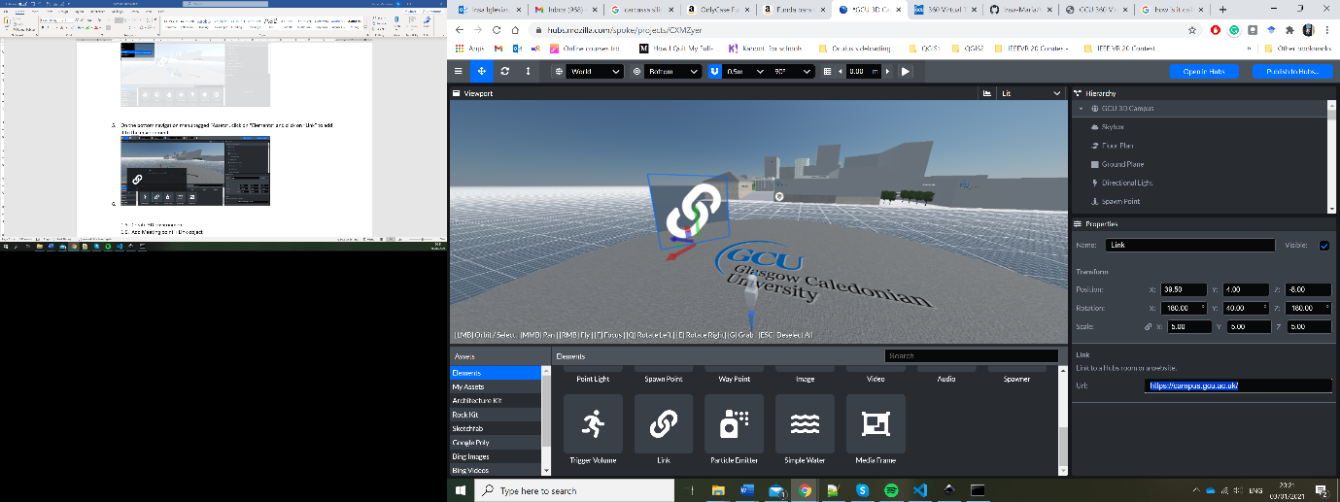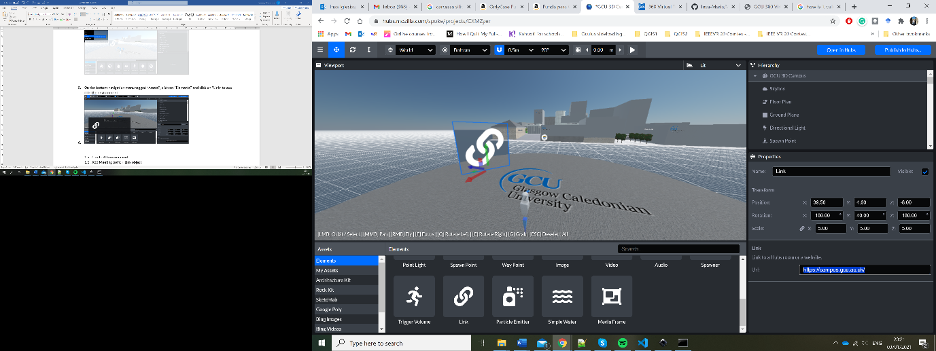

1. Click on the menu button (displayed as ≡) > “File” > “Save Project”
2. Click on the top left button “Publish to Hubs”

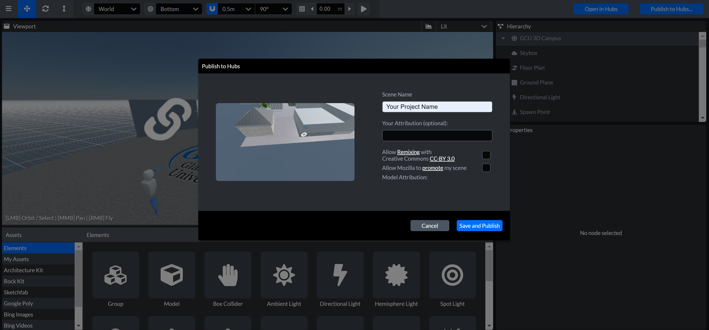

1. Set a “Scene Name” and click on “Save and Publish”
2. A “Performance Check” window appears and then click on “Publish Scene”
3. Once it has been published successfully, click on “View Your scene”.

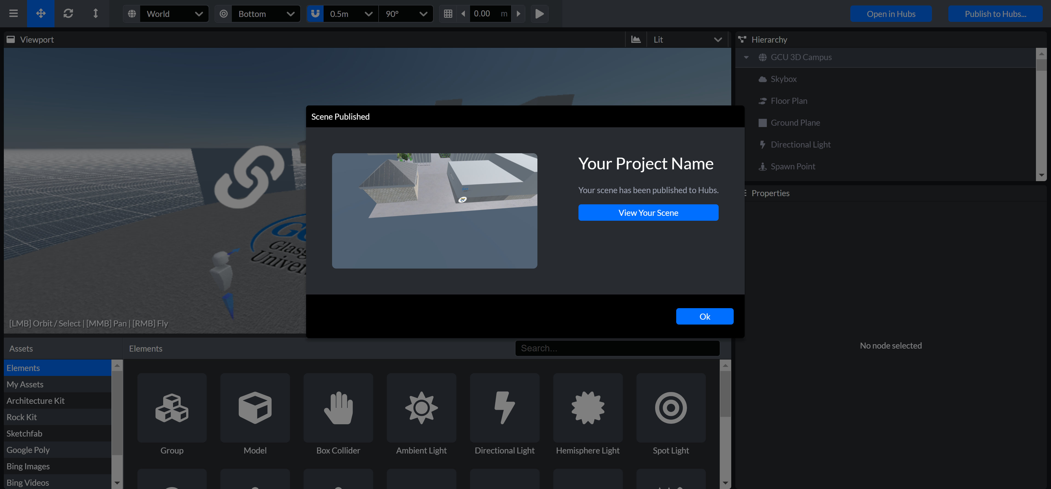  
Note: you can also view your project clicking on the top left button “Open in Hubs”, but you need first to save and publish it to see the last version you created.

## Link 360 Virtual Tour (Step 4) with 3D Hubs (step 2)

### Open Mozilla Hub and Share

1. In Mozilla Hubs-Spoke, click on the top left button “Open in Hubs” to view your scene
2. Click on “Create a room with this scene”

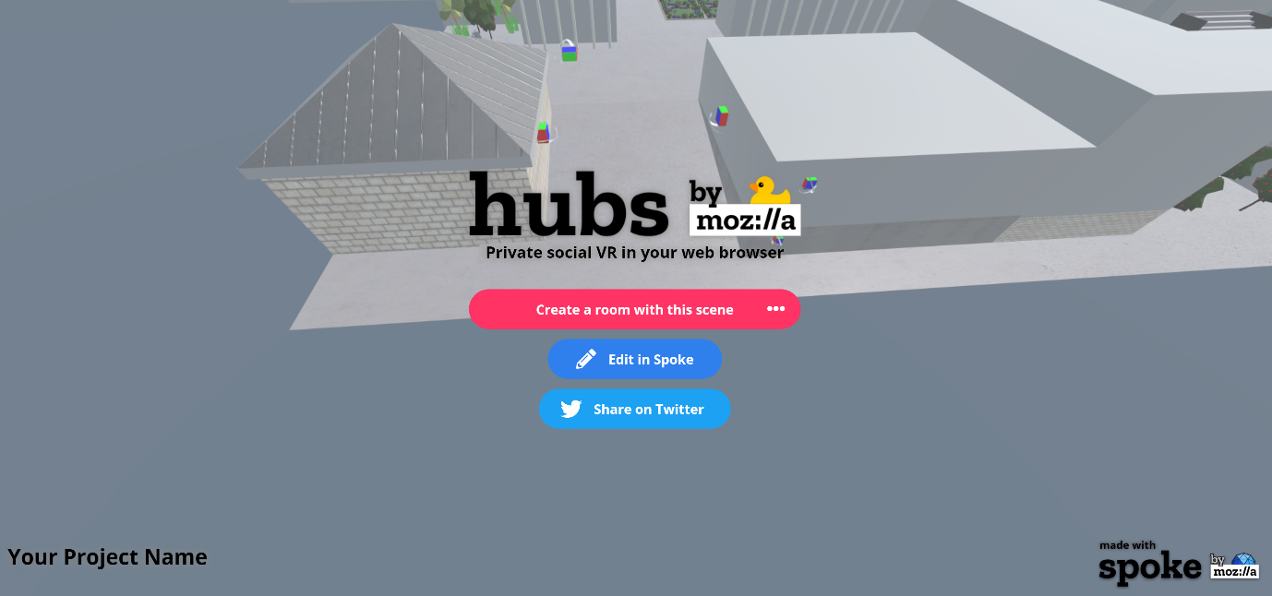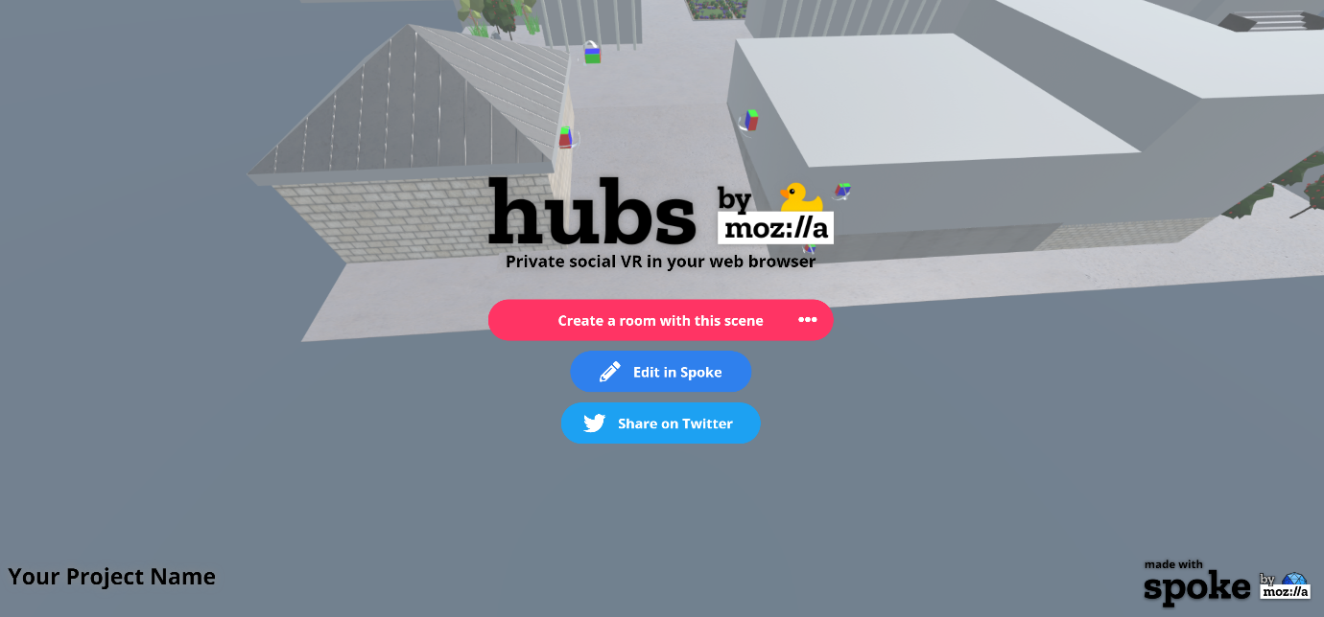

1. Click on the top button “Share”

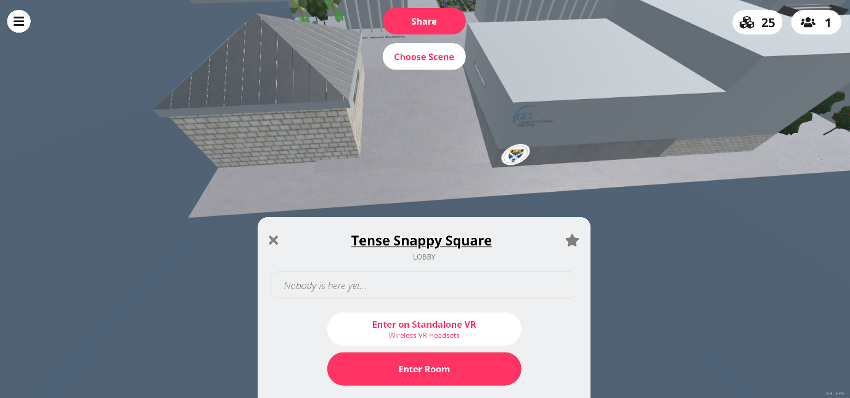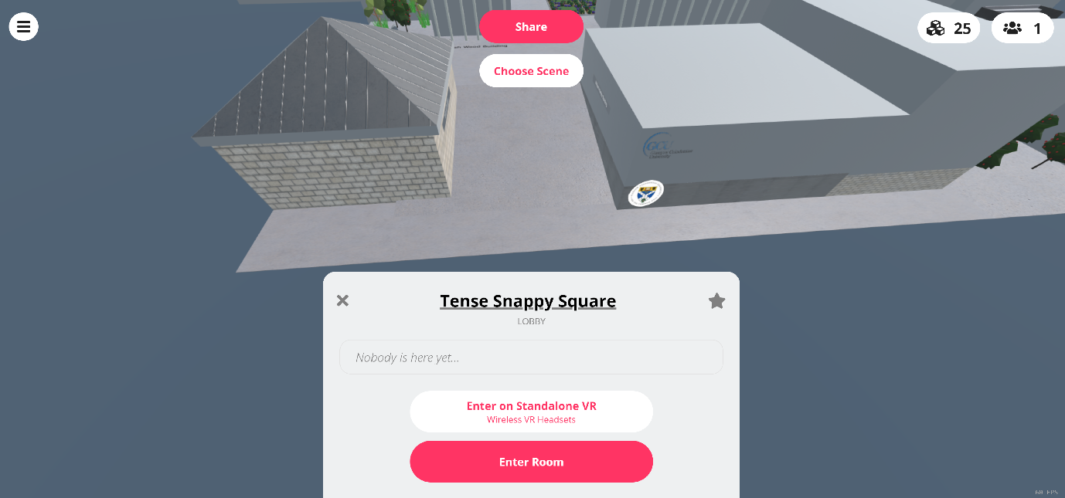

1. Copy the text of the bottom box (starts with “<iframe sc….”).   
   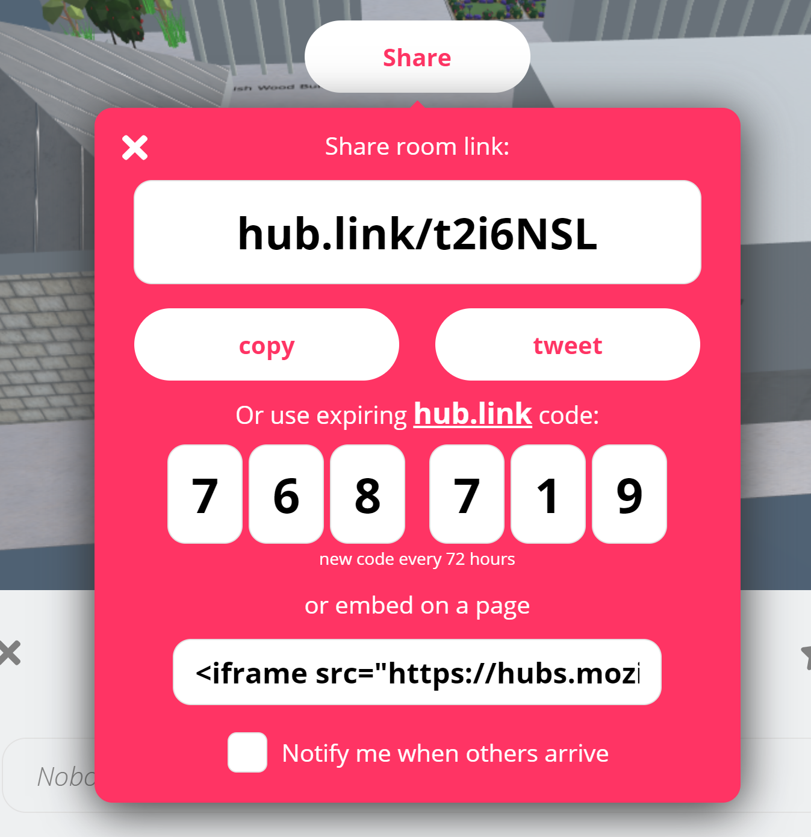

For example:   
<iframe src="https://hubs.mozilla.com/t2i6NSL/tense-snappy-square?embed_token=19774a93784d0919379e90d22684ceda" style="width: 1024px; height: 768px;" allow="microphone; camera; vr; speaker;"></iframe>

1. From the copied text, save for later the Mozilla Hub link (highlighted in yellow). This will be the link you share with other visitors.  
   For example: <https://hubs.mozilla.com/t2i6NSL/tense-snappy-square?embed_token=19774a93784d0919379e90d22684ceda>

### Link 360 VT and Mozilla Hub

* 1. Add window to insert user name + hub link
  2. Add button to access 360 VT